ESP32 vs ESP8266 – Pros and Cons

May 1, 2019 By [Sara Santos](https://makeradvisor.com/author/sarasantos/)

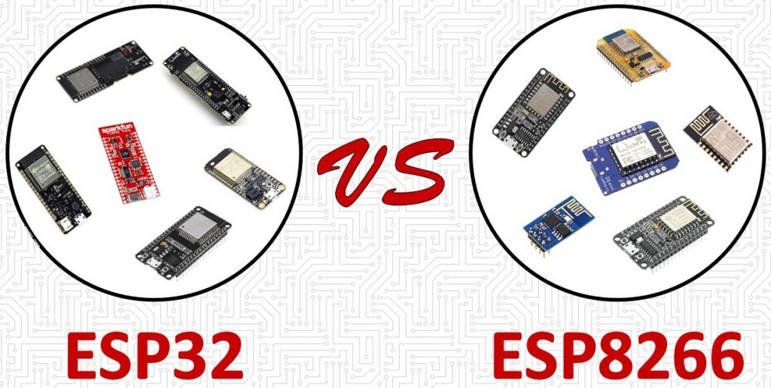

Should you use ESP32 or ESP8266 in your projects? What’s the difference between ESP32 and ESP8266? In this article we’re going answer these questions by comparing the ESP32 with the ESP8266 and cover the pros and cons of each board.

The ESP32 and ESP8266 are cheap Wi-Fi modules perfectly suited for DIY projects in the Internet of Things (IoT) field.

Both chips have a 32-bit processor. The ESP32 is dual core 160MHz to 240MHz CPU whereas the ESP8266 is a single core processor that runs at 80MHz.

These modules come with GPIOs that support a wide variety of protocols like SPI, I2C, UART, and more. The best part is that they come with wireless networking included, which makes them apart from other microcontrollers like the [Arduino](https://makeradvisor.com/best-arduino-starter-kits/). This means that you can easily control and monitor devices remotely via Wi-Fi or Bluetooth (in case of ESP32) for a very low price.

Specifications: ESP32 vs ESP8266

The [ESP32](https://makeradvisor.com/esp32-development-boards-review-comparison/) is the [ESP8266](https://makeradvisor.com/best-esp8266-wi-fi-development-board/) successor. It adds an [extra CPU core](https://randomnerdtutorials.com/esp32-dual-core-arduino-ide/), faster Wi-Fi, more GPIOs, and supports Bluetooth 4.2 and [Bluetooth low energy](https://randomnerdtutorials.com/esp32-bluetooth-low-energy-ble-arduino-ide/). Additionally, the ESP32 comes with touch sensitive pins that can be used to wake up the ESP32 from deep sleep, a [built-in hall effect sensor](https://randomnerdtutorials.com/esp32-hall-effect-sensor/) and a built-in temperature sensor.

Both boards are very cheap, but the ESP32 costs slightly more. While the ESP32 can cost around $6 to $12, the ESP8266 can cost $4 to $6 (but it really depends on where you get them).

The following table shows the main differences between the ESP8266 and the ESP32 chips (table adapted from: [AMICA_IO](https://twitter.com/Amica_IO/status/713271719230709761/photo/1)).

|  | **ESP8266** | **ESP32** |
| --- | --- | --- |
|  | [https://makeradvisor.com/wp-content/uploads/2018/04/esp8266-chip.png](https://makeradvisor.com/best-esp8266-wi-fi-development-board/) | [https://makeradvisor.com/wp-content/uploads/2018/04/esp32-chip.png](https://makeradvisor.com/esp32-development-boards-review-comparison/) |
| **MCU** | Xtensa Single-core 32-bit L106 | Xtensa Dual-Core 32-bit LX6 with 600 DMIPS |
| **802.11 b/g/n Wi-Fi** | HT20 | HT40 |
| **Bluetooth** | **X** | Bluetooth 4.2 and BLE |
| **Typical Frequency** | 80 MHz | 160 MHz |
| **SRAM** | **X** | **✓** |
| **Flash** | **X** | **✓** |
| **GPIO** | 17 | 36 |
| **Hardware /Software PWM** | None / 8 channels | None / 16 channels |
| **SPI/I2C/I2S/UART** | 2/1/2/2 | 4/2/2/2 |
| **ADC** | 10-bit | 12-bit |
| **CAN** | **X** | **✓** |
| **Ethernet MAC Interface** | **X** | **✓** |
| **Touch Sensor** | **X** | **✓** |
| **Temperature Sensor** | **X** | **✓** |
| **Hall effect sensor** | **X** | **✓** |
| **Working Temperature** | -40ºC to 125ºC | -40ºC to 125ºC |
| **Price** | $ (3$ - $6) | $$ ($6 - $12) |